LAB – 2 REPORT
Name: Ozan Berk Gultegin
Submission Date:

Purpose of the Work
The objective of this lab is to perform an analysis of speech signals in the time domain. The tasks include plotting time-domain waveforms, computing energy and zero-crossing rate (ZCR), selecting and analyzing different segments of speech (voiced, unvoiced, and background noise), and estimating the fundamental frequency using autocorrelation.

Work Results
  - II.I Graphical Result
- Voiced Signal

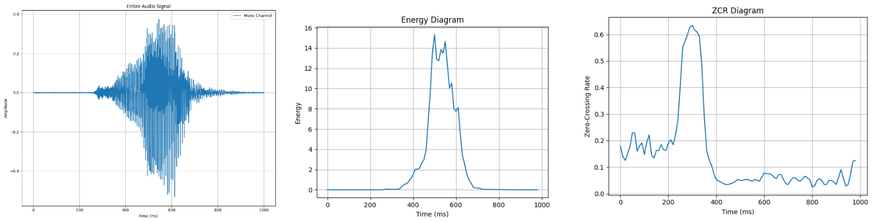
  - Figure 1.1: Voiced signal diagrams.
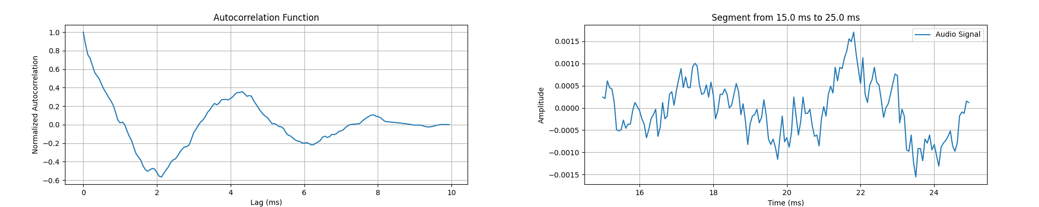
  - Figure 1.2: Voiced signal autocorrelation and segmented time-domain representation.

- Unvoiced Signal
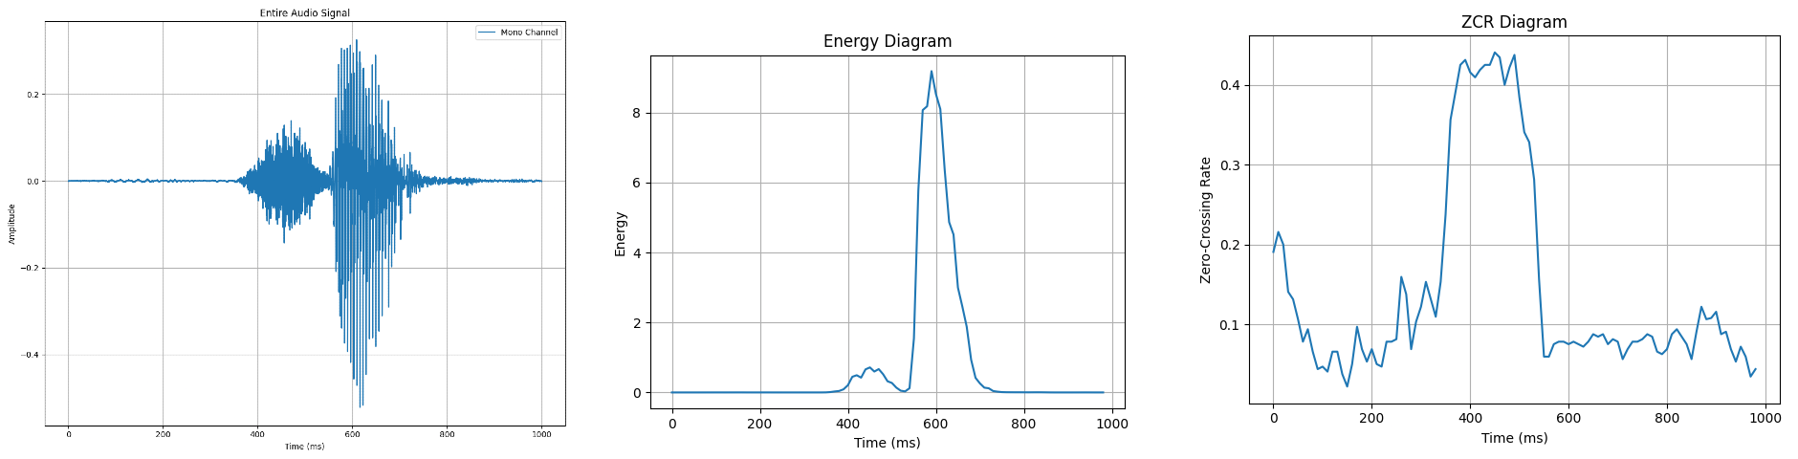
  - Figure 2.1: Unvoiced signal diagrams.
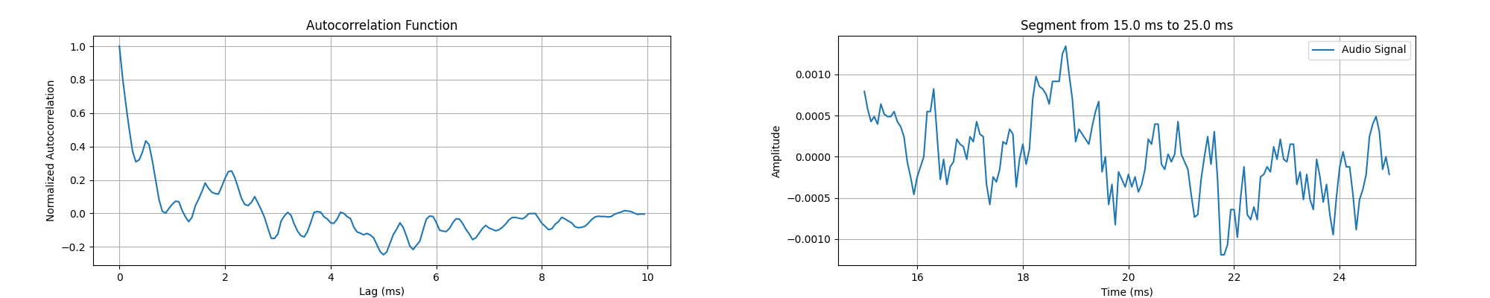
  - Figure 2.2: Unvoiced signal autocorrelation and segmented time-domain representation.
- Background Voice Signal
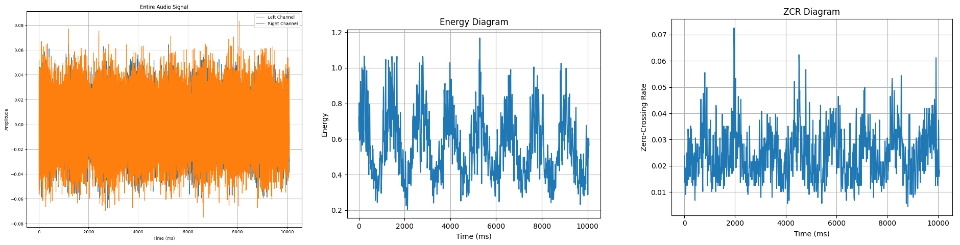
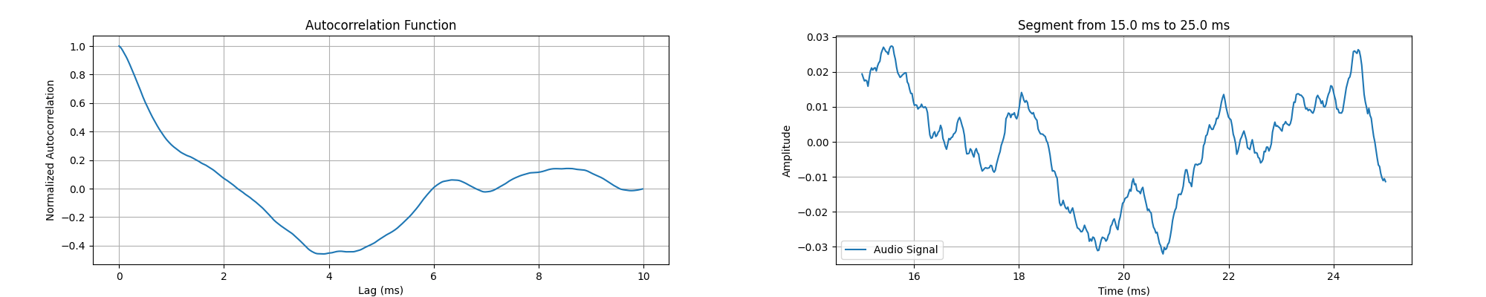
Information about the scanned signal (15-25ms segment):
- Voiced Signal:
Fundamental Frequency: 941.18 Hz
- Unvoiced Signal:
Fundamental Frequency: 2000.00 Hz
- Background Signal:
Fundamental Frequency: 260.95 Hz

Summary and Conclusion
This lab provided practical experience with time-domain speech signal analysis using waveform inspection, energy and zero-crossing rate (ZCR) calculations, and autocorrelation-based fundamental frequency estimation.
Key observations from the analysis include:
- Energy: The voiced speech signal exhibited the highest energy, followed by the unvoiced signal, while background noise had significantly lower energy approximately one-tenth that of the voiced signal.

- Zero-Crossing Rate (ZCR): Like the energy pattern, the voiced signal also had the highest ZCR, closely followed by the unvoiced signal. In contrast, background noise showed a much lower ZCR again around one-tenth of the other two. This indicates a more stable signal in the background segment with fewer sign changes.

- Autocorrelation: The voiced and background signals shared some visual similarities in their autocorrelation functions, likely due to low-frequency periodicity. However, the unvoiced signal displayed erratic fluctuations in its autocorrelation curve, with multiple irregular peaks and dips, highlighting its aperiodic, noisy nature.
These results demonstrate how energy, ZCR, and autocorrelation can be used collectively to characterize and differentiate between types of sounds in speech processing. Voiced signals are more structured and periodic, whereas unvoiced and background sounds are more noise-like and less predictable.

